Direktoratet for Rådgivende Funktioner  Spørgeskema vedrørende RU's bidrag til Gruppen af Højtstående Uafhængige Interesserede Parter vedrørende Administrative Byrder  Rapport om god praksis i medlemsstaterne for gennemførelse af EU-lovgivning på den mindst byrdefulde måde |  | 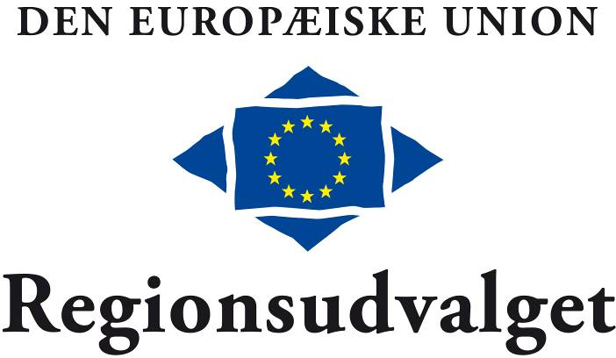

Medlemsstat:
Navn på region, lokal myndighed:
Ansvarlig administrativ myndighed:
Primær kontaktperson:
E-mail:
Telefon:

1. Identificering af god praksis:
Angiv venligst følgende, hvis muligt:
- initiativets navn
- materielt område

- mål for bedste praksis

- relevant EU-lovgivning

- relevant national / regional / lokal lovgivning

2. Udførlig beskrivelse af god praksis og virkningerne heraf:
Angiv venligst følgende, hvis muligt:
Hvad er de væsentligste elementer?
Hvilke virkninger er der for erhvervslivet, særligt SMV'er?
(hvem er berørt, hvilke procedurer strømlines, hvordan gøres dette)
Hvilke virkninger er der for de offentlige forvaltninger?
(hvem er berørt, hvilke procedurer strømlines, hvordan gøres dette)
Dato for gennemførelse
Forbedringer ift. tidligere praksis
Hvordan er proceduren målt på tid, varighed og/eller kompleksitet blevet forbedret i kraft af den gode praksis?
Hvordan er proceduren målt på omkostninger blevet forbedret i kraft af den gode praksis?
E-forvaltningselementer

Størrelsen af omkostningsreduktionen, hvis der kan sættes tal på
Andre mulige positive virkninger af den gode praksis, f.eks. for konkurrenceevnen, væksten, på tværs af grænserne (mobilitet, fri bevægelighed for arbejdstagere, varer, kapital og tjenesteydelser)

3. Supplerende oplysninger:
Supplerende oplysninger om den gode praksis, som De finder relevante
Hjemmeside med yderligere oplysninger
Hvis den gode praksis, De omtaler, vedrører et bestemt direktiv eller en bestemt forordning, bedes De venligst anføre eventuelle ideer til, hvordan direktivet/forordningen kunne forenkles med det mål at reducere den administrative byrde.

Spørgeskemaet bedes udfyldt og returneret senest den 28. februar 2011:

E-mail: civex@cor.europa.eu

Postadresse:
Committee of the Regions
Directorate for Consultative Work
Consultation on Good Practices for the Implementation of EU legislation
c/o Mr. Emmanouil Dardoufas, VMA 07/51
Rue Belliard 101
1040 Brussels

Hvis De angiver mere end et eksempel, ser vi gerne, at eksemplerne dækker forskellige sektorer (f.eks. samhørighed, offentlige indkøb osv.) og emner (e-forvaltning, risikobaseret tilgang, synergistyring osv.), da der kan være begrænset plads til de enkelte sektorer i den endelige rapport.

De bedes venligst anvende en ny formular til hvert enkelt eksempel på god praksis.

Oplysningerne bør være så kortfattede og præcise som muligt. Supplerende information kan vedlægges spørgeskemaet.

Ansvarsfraskrivelse.
Opfølgning af besvarelsen indebærer behandling af personlige oplysninger (navn, kontaktoplysninger osv.) i en fil. Ønsker De yderligere oplysninger eller ønsker De at udøve Deres rettigheder i medfør af forordning (EF) nr. 45/2001 (f.eks. adgang til eller berigtigelse af oplysninger), kontakt da venligst den registeransvarlige (chefen for netværks- og subsidiaritetsenheden) på subsidiarity@cor.europa.eu. De kan også kontakte Regionsudvalgets databeskyttelsesansvarlige (data.protection@cor.europa.eu). De har til enhver tid ret til at henvende Dem til den europæiske tilsynsførende for databeskyttelse (www.edps.europa.eu). Deres individuelle besvarelse vil ikke blive offentliggjort.
*

* *

Appendix

HLG Report on good practice in Member States to implement
EU legislation in the least burdensome way

INDICATIVE SELECTION OF POLICY AREAS/LEGAL INSTRUMENTS
on which good practices are being sought

Answers to the questionnaire from CoR members and other local and regional stakeholders could primarily concern the policy areas/ legal instruments from the Action Programme on the Reduction of Administrative Burdens and its extension of most concern to local and regional authorities in terms of administrative burden and its reduction potential, and have been selected.

An indicative selection follows:

Cohesion policy
- Council Regulation (EC) No 1260/1999 of 21 June 1999 laying down general provisions on the Structural Funds, as amended by Council Regulation (EC) No 1105/2003 of 26 May 2003

Public procurement
- Directive 2004/18/EC of the European Parliament and of the Council of 31 March 2004 on the coordination of procedures for the award of public work contracts, public supply contracts and public service contracts
- Directive 2004/17/EC of the European Parliament and of the Council coordinating the procurement procedures of entities operating in the water, energy, transport and postal services sectors (including Commission Regulation (EC) No 1564/2005 of 7 September 2005 establishing standard forms for the publication of notices in the framework of public procurement procedures pursuant to that directive)

Environment
- Directive 2003/105/EC of the European Parliament and of the Council of 16 December 2003 amending Council Directive 96/82/EC on the control of major accident hazards involving dangerous substances
- Regulation (EC) No 1013/2006 of the European Parliament and of the Council of 14 June 2006 on shipments of waste
- Council Directive 96/61/EC of 24 September 1996 concerning integrated pollution prevention and control (as amended by Regulation (EC) No 166/2006 of the European Parliament and of the Council of 18 January 2006 concerning the establishment of a European Pollutant Release and Transfer Register and amending Council Directives 91/689/EEC and 96/61/EC)
- Waste Electrical and Electronic Equipment (WEEE) directive 2002/96/EC
- Directive 2000/53/EC of the European Parliament and of the Council of 18 September 2000 on end-of life vehicles
- Directive 2010/31/EU of the European Parliament and of the Council of 19 May 2010 on the energy performance of buildings
- Directive 2009/28/EC of the European Parliament and of the Council of 23 April 2009 on the promotion of the use of energy from renewable sources

Environment – waste legislation
- Decision 2000/532/EC establishing a list of wastes (+ 3 amendments)
- European Parliament and Council Directive 94/62/EC on packaging and packaging waste (+ 6 Commission implementing Decisions (on the identification system for packaging materials, on formats relating to the database system, on derogation and on national measures in 3 Member States)
- Directive 2004/12/EC of the European Parliament and of the Council of 11 February 2004 amending Directive 94/62/EC on packaging and packaging waste (+3 amendments)
- Regulation (EC) No 2150/2002 on waste statistics

Environment – Water
- Council Directive 98/83/EC on the quality of water intended for human consumption
- Directive 2008/105/EC on environmental quality standards in the field of water policy (3) + transitional measures for new Member States
- Directive 2000/60/EC of the European Parliament and of the Council of 23 October 2000 establishing a framework for Community action in the field of water policy

Processing of personal data
- Directive 95/46/EC of the European Parliament and of the Council of 24 October 1995 on the protection of individuals with regard to the processing of personal data and on the free movement of such data

_____________

Hvis relevant.
Se bilag.
Hvis relevant - hvis der er tale om en horisontal institutionel struktur eller initiativ i Deres region eller by, kan De lade feltet stå tomt.
Hvis relevant.
COM (2007) 23 final.
The Commission has extended the scope of the action programme in January 2009 so as to cover an additional 30 legislative instruments in the interest of taking into account stakeholders' ideas, thus raising the total number of legislative instruments therein to 72 [COM (2009) 16 final, annex 9]. In October 2009 the outgoing Commission suggested an additional 28 legislative acts, to which the Action Programme could be potentially extended by the current Commission [COM (2009) 544 final, annex F]. The HLG has adopted an opinion on a possible future extension of the Action Programme with additional suggestions in October 2010. A decision on the actual extension still remains to be taken by the Commission.
HLG opinion on the future extension of the Action Plan – October 2010.
HLG opinion on the future extension of the Action Plan – October 2010.
European Commission extension proposal October 2009 – COM (2009) 544 annex F.
European Commission extension proposal October 2009 – COM (2009) 544 annex F.
European Commission extension proposal October 2009 – COM (2009) 544 annex F.
European Commission extension proposal October 2009 – COM (2009) 544 annex F.
European Commission extension proposal October 2009 – COM (2009) 544 annex F.
European Commission extension proposal October 2009 – COM (2009) 544 annex F.
HLG opinion on the future extension of the Action Plan – October 2010.
European Commission extension proposal October 2009 – COM (2009) 544 annex F and HLG opinion on the future extension of the Action Plan – October 2010.

